“ 금융은 튼튼하게, 소비자는 행복하게”
Notice of Customer
Due Diligence
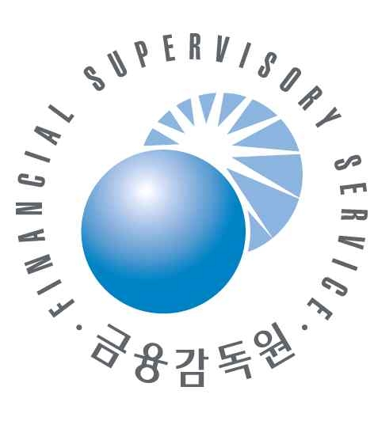
Your financial transaction may be rejected if you reject customer due diligence.
'Customer Due Diligence' is that a financial company takes a reasonable
care of customers checking of beneficiary owner, purpose of transaction and
customer in order not to use financial transaction or service for illegal
activities such as money laundering.
A financial company should confirm customer's identification like name, resident registry number and the purpose of financial transaction, source of fund on customers who newly opened an account or one-off transaction more than 20 mio KRW (10,000 U$), and from 2016 in accordance with revised [ACT ON REPORTING AND USING SPECIFIED FINANCIAL TRANSACTION INFORMATION] a financial company shall reject customer's financial transaction which the customer reject customer due diligence.
And it would be grateful if you cooperate a staff's request of a financial company because customer information which was acquired in the course of customer due diligence is managed under the purpose of anti-money laundering and it is prohibited to reveal it under [Financial Secrecy Act] and [Credit Information Act]
Commissioner of KoFIU ·Governor of FSS

